CMPEN/EE454: Computer Vision

Computer Project # 3:

Mathematical Morphology, Pyramid Decomposition, and Edge Detection

Zhenning Zhao, Michael Mikulski, Kyle McCormick

Date: October 25th, 2012

    - Objectives
The primary objective of project 3 is to use Mathematical Morphology, Pyramid Decomposition, and Edge Detection on two given images using Matlab.
    - Methods
For part 1 we were to remove the streaking from “match2a”. We used the opening algorithm in which we used the erosion method and then applied the dilation technique. After using many sizes of shapes and sizes of masks we decided that a 3x1 vertical mask gave us the best results. For “match3a” in Part 1, we were to remove the salt and pepper noise. After many attempts we observed that the diamond mask give us the best results by eliminating all the salt and pepper noise while also reducing damage on the regions of interest.
For part 2 we were to use Pyramid Decomposition on “lenna”. We used Matlab’s impyramid function to both reduce and expand the image appropriately. We first reduced the image (Ix) from the original image and then expanded the image (Ixe) appropriately. We continued this method until we received an image size of 32x32 from an original image size of 256x256.

(ADD PART 3 METOD)

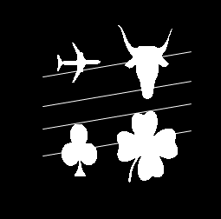
    - Results

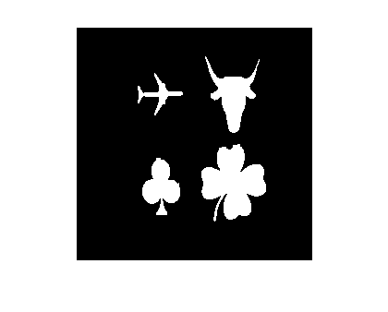
Figure 1. Original image “match2a”

Figure 2. Image “match2a” after Opening algorithm

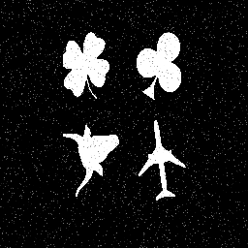

Figure 3. Original image “match3a”
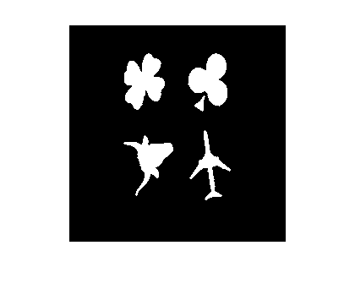

Figure 4. Image “match3a” after Opening algorithm
using diamond shape mask

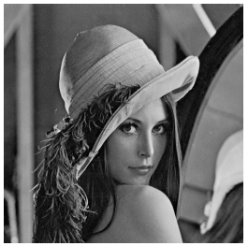

Figure 5. Original image “lenna”

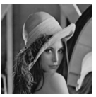

Figure 6. “lenna” image after first reduction (128x128)

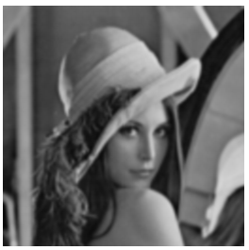

Figure 7. “lenna” image after first expansion back to 256x256

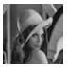

Figure 8. “lenna” image after second reduction (64x64)

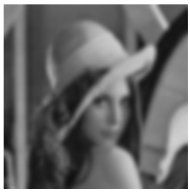

Figure 9. “lenna” image after two expansions back to 256x256

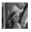

Figure 10. “lenna” image after third reduction (32x32)
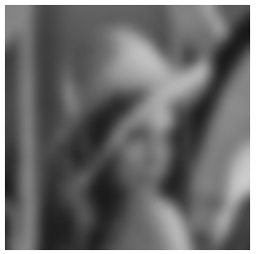

Figure 11. “lenna” image after three expansions back to 256x256

Figure 12. “lenna” image after fourth reduction(16x16). Image is not needed but provided to
complement the fourth expansion image



.

Figure 13. “lenna” image after fourth expansion back to 256x256

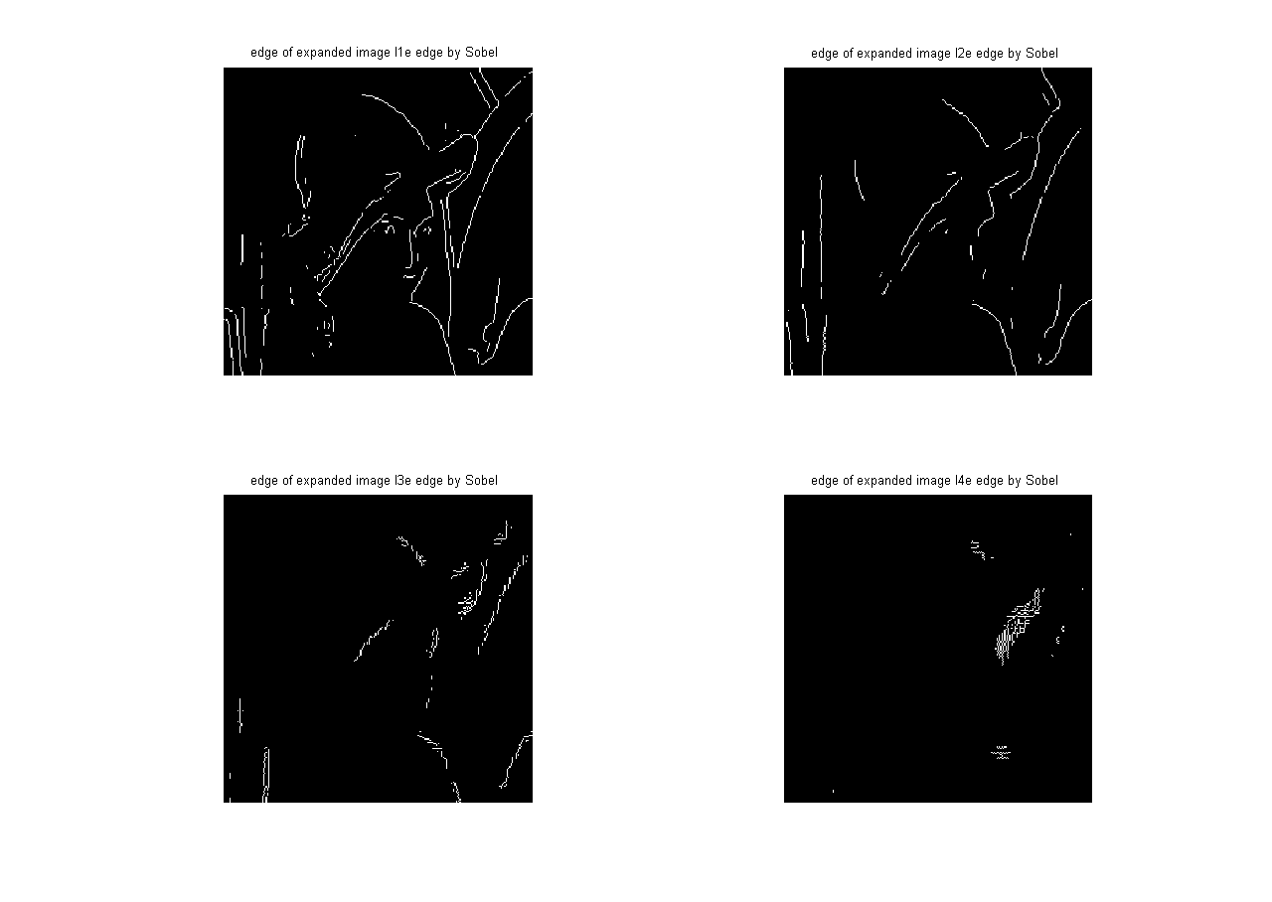

Figure 14. “lenna” image after using the sobel edge detector on the expanded images I1e, I2e, I3e, and I4e

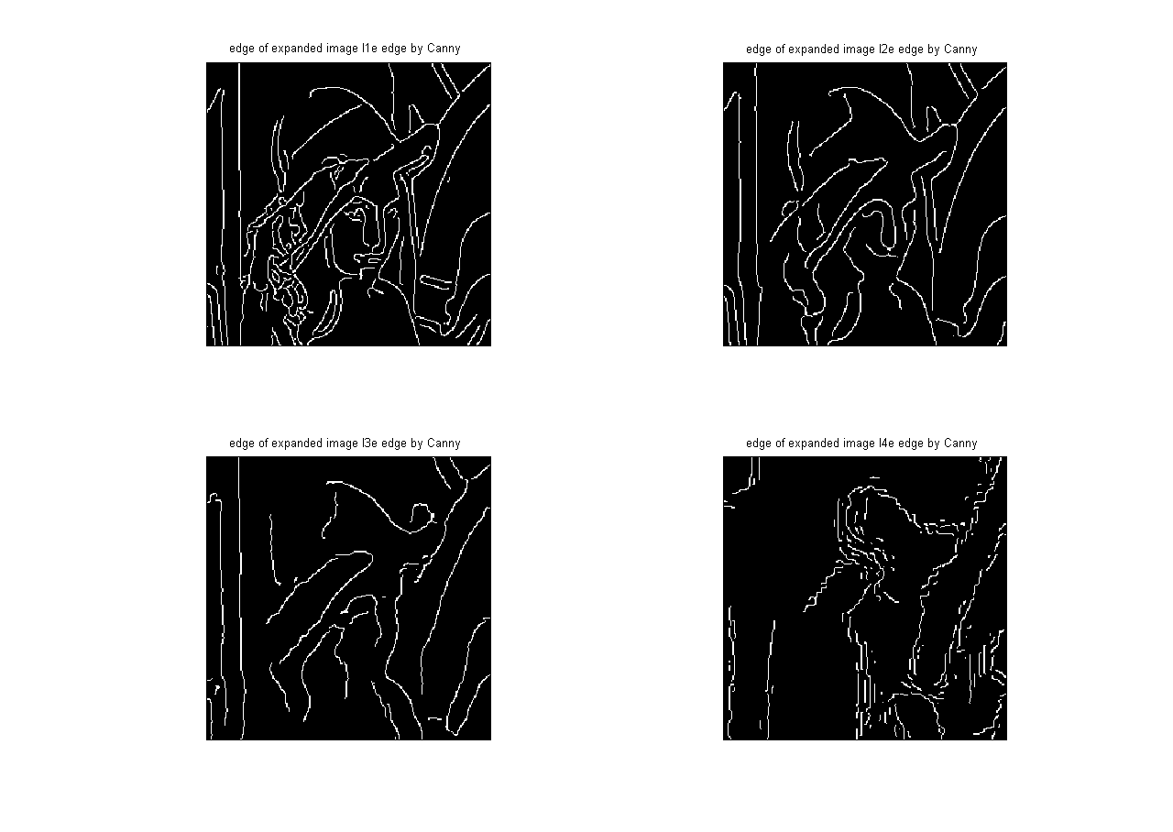

Figure 13. After using the canny edge detector on the expanded images I1e, I2e, I3e, and I4e

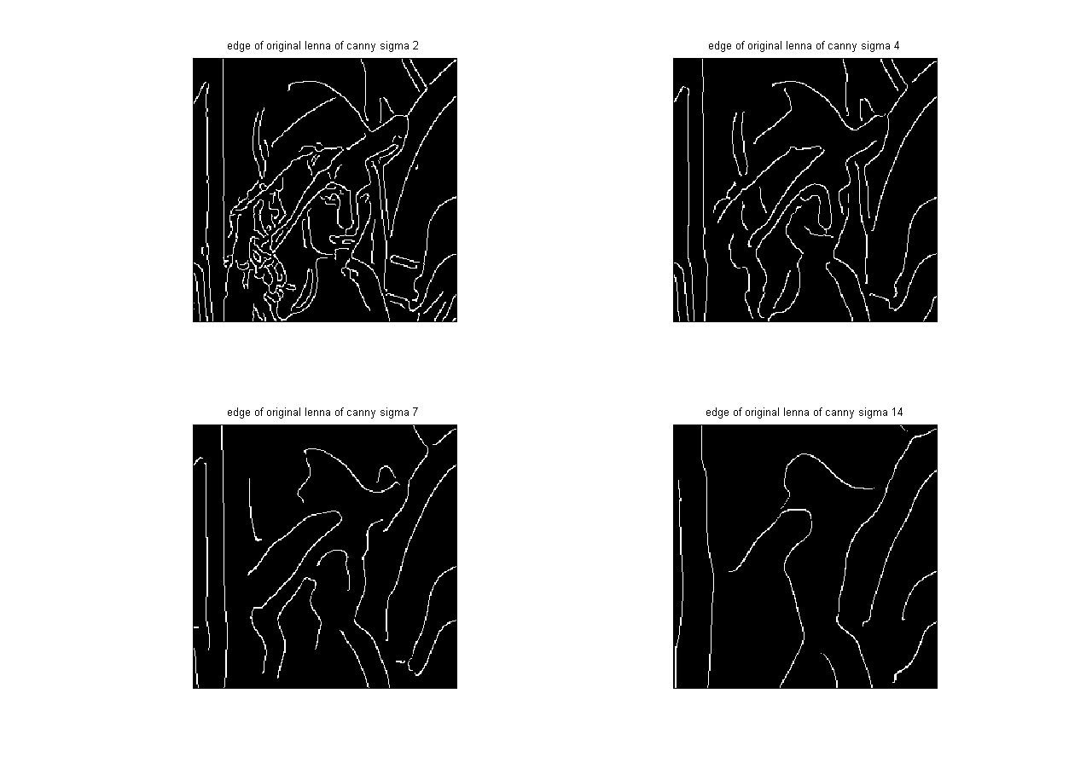

Figure 13. After using the canny edge detector on the original “lenna” image by sigma values 2, 4, 7, and 14

(ADD OBSERVATIONS TO RESULTS)
Give detailed observations and/or analysis of all results.
Also, ask yourself the following general questions:
- Are the results what you were expecting they would be? If not, why not?
- Do you think it's because the algorithm is not the appropriate one, or because your implementation has a bug?

When observing our results we saw that with the correct sigma values in figure 13, we can achieve the similar results of figure 12. This would be more efficient as we would not need to perform reduction and expansion techniques.
Be sure to answer any questions the project write-up may pose! I often pose such questions to probe you on certain project knowledge.
    - Conclusions
For part 1’s “match2a” image we came to the conclusion that using a vertical 3x1 mask using the opening algorithm gave us the best results. For “match3a” we used a diamond shape mask using the opening algorithm to remove all the salt and pepper noise without damaging the desired regions. For part 2’s “lenna” image we used Matlab’s impyramid function to both reduce and expand the image as instructed in the project description. We realized we needed to take into consideration the border of “match2a” and “match3a” when using the filters in order to receive the desired result. (ADD PART 3 CONCLUSION)

